How to create an Artifact!
These instructions are for uploading proof of your liability insurance in the semester before your student teaching.

Step One
Login into TK20 and click on artifacts.
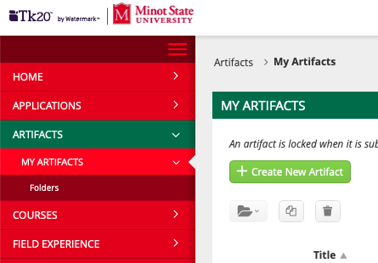

Step Two
Click create new artifacts and on the drop-down arrow. Find Professional Liability Insurance and click create.
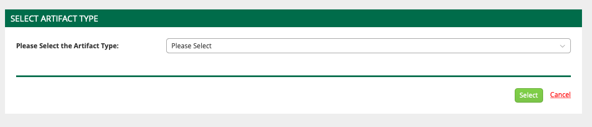

Step Three
Upload file and press create when finished!
